EncryptFactoryData   
User Guide

(Command line tool for   
APDCAM and APDCAM-10G)

Version: 1.0

Last modified: 04.02.2016.

1. **Introduction**

This document describes details about how to use EncryptFactoryData software. This software is capable to run under Windows and Linux as well. EncryptFactoryData was tested under the following operating systems:

* Windows 7, 64bit
* CentOS 6, 64bit

1. **Requirements**
   * Visual C++2013 Redistributables installed to be able to run the software (for windows only)
   * Config file with necessary parameters for and APDCAM or and APDCAM-10G
2. **Using the software**

The software only have one input parameter which is the file name which contains factory data for an APDCAM or and APDCAM-10G. If this argument is missing then the software will display tho following:

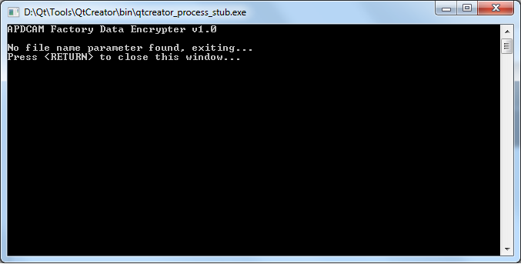

If everything is fine and the filename argument is present then the software will encrypt the data in file and creates a new file with the name „FactData_encrypted.dat” in the same directory. In this case the software output looks like this:

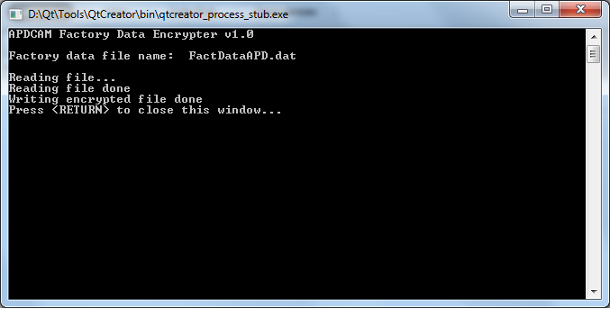

After the process was successfully finished, the file created can be used as an input for the APDWriteFactoryData application.

1. **Support**

If you have any further questions of want to report a bug please contact us by email:

[support@fusioninstruments.com](mailto:support@fusioninstruments.com?subject=Encrypt%20Factory%20Data)